CIRCUIT ANALYSIS LAB_6
Name: Muhammad Uzair
Reg No: 2025-CE-112
Date: 21stApril,2026

Experiment # 1:
Circuit Made In Proteus: KCL
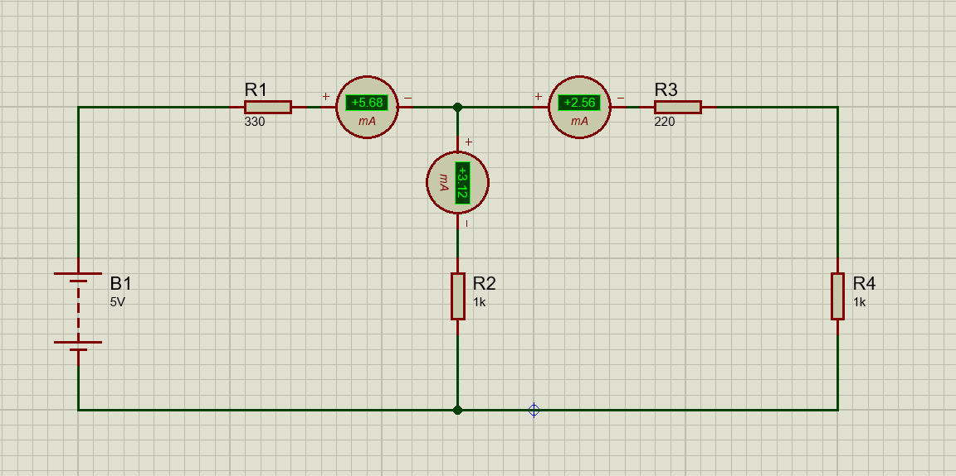
Construction:
- Insert four resistors of 330Ω, 1kΩ, 220Ω and 1kΩ resistance respectively.
- Insert DC Battery and set it up to 5V.
- Connect DC Battery Source with R₁.
- Connect other terminal of R₁ with R₂, R₃, and R₄ such that it forms a parallel combination with R₂ and then together they form series with R₃ and R₄.
- Insert Ammeter in series to measure currents I₁, I₂, and I₃.
- You will observe KCL is proved in the end as I₁ = I₂ + I₃.
- Observe with different voltages like 15V and 25V.

Experiment # 2:
Circuit Made In Proteus: KVL
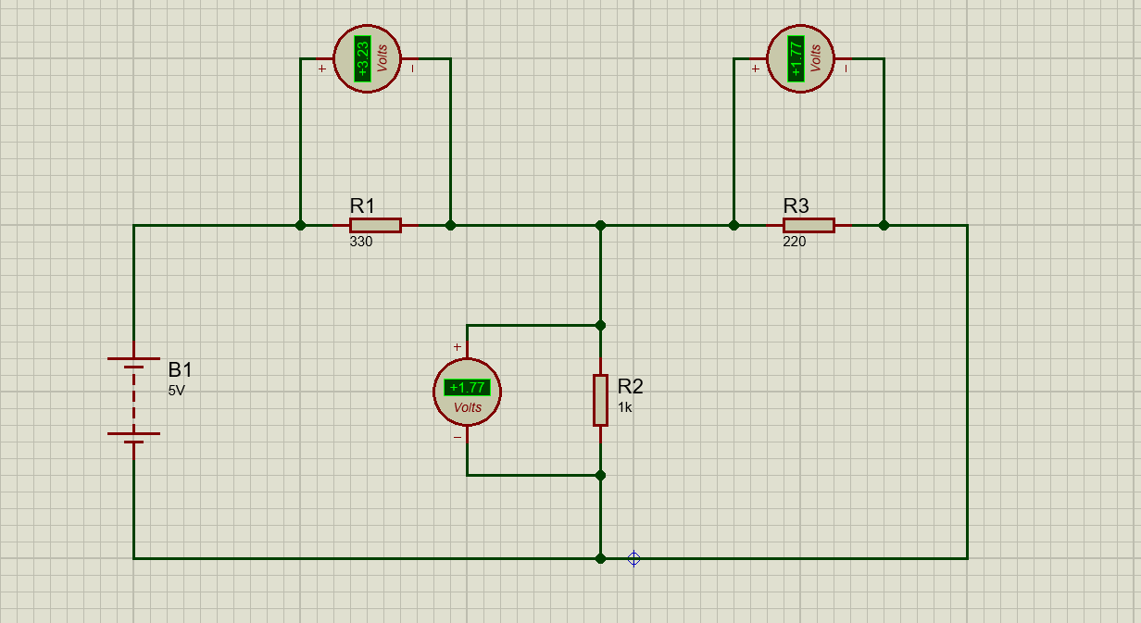
Construction:
- Insert three resistors of 330Ω, 1kΩ and 220Ω resistance respectively.
- Insert DC Battery and set it up to 5V.
- Connect DC Battery Source with R₁.
- Connect other terminal of R₁ with R₂, and R₃ such that it forms a parallel combination with R₂ and then together they form series with R₃.
- Insert Voltmeters in parallel to measure V₁, V₂, and V₃.
- You will observe KVL is proved in the end as E₁ = V₁ + V₂.
- Observe with different voltages like 10V and 15V.

